ECE 100: Linear Electronic Systems

Professor: Drew Hall

Lab 1:

Passive RLC Circuits

Andy Tu PID: A17650683

10/13/2023

# Table of Contents

**Table of Contents 2**

**Abstract 4**

**Experimental Procedure 5**

Section 1: Low-Pass RLC Circuit 5

Figure 1: Schematic of Low-Pass filter 5

Section 2: High-pass and Band-pass RLC circuits: 6

Figure 2: Schematic of High-Pass filter 6

Figure 3: Schematic of Band-Pass filter 6

Section 3: Mystery Filter 7

Figure 4: Schematic of Mystery Filter 7

**Results 8**

Section 1: Low-Pass RLC Circuit 8

Part A) 8

Part B) 9

Part C) 10

Figure 5: Magnitude plot of low-pass in Linear Scale 10

Figure 6: Magnitude plot of low-pass filter in dB vs log frequency 11

Figure 7: Phase plot of low-pass filter 11

Part D) 12

Figure 8: Magnitude plot of low-pass filter with Peak Values Labeled 13

Section 2: High-pass and Band-pass RLC Circuits 14

Part A) 14

Part B) 15

Figure 9: Magnitude plot of high-pass filter in dB vs log frequency 15

Figure 10: Phase plot of high-pass filter 15

Figure 11: Magnitude plot of band-pass filter in dB vs log frequency 16

Figure 12: Phase plot of band-pass filter 17

Section 3: Mystery Filter 17

Figure 13: Magnitude plot of mystery filter in dB vs log frequency 18

Figure 14: Phase plot of mystery filter 19

Section 4: Linear System Tools 20

Part A) 20

Figure 15: Step Response of low-pass filter 20

Part B) 21

Figure 16: Overshoot % vs ζ 21

**Conclusion 22**

**MATLAB Code 23**

Problem 1: Low-pass RLC Circuit: 23

Problem 2: High-pass and Band-pass RLC circuits: 26

Problem 3: Mystery Filter 29

Problem 4: Linear System Tools 31

a) Step Responses for Transfer Functions 31

b) Plot Overshoot 31

# 

# Abstract

The purpose of this lab was to analyze various RLC circuits and their properties as they behave as different frequency filters. By using MATLAB we analyzed four different filters (low-, band-, high-pass, and mystery), testing each with different 𝜁 (zeta) values. We created Bode plots comparing the magnitude and phase for each filter with respect to frequency. This showed us the effects of rearranging an RLC circuit without adding or removing parts.

# Experimental Procedure

Tools: MATLAB software

## 

## 

## 

## Section 1: Low-Pass RLC Circuit

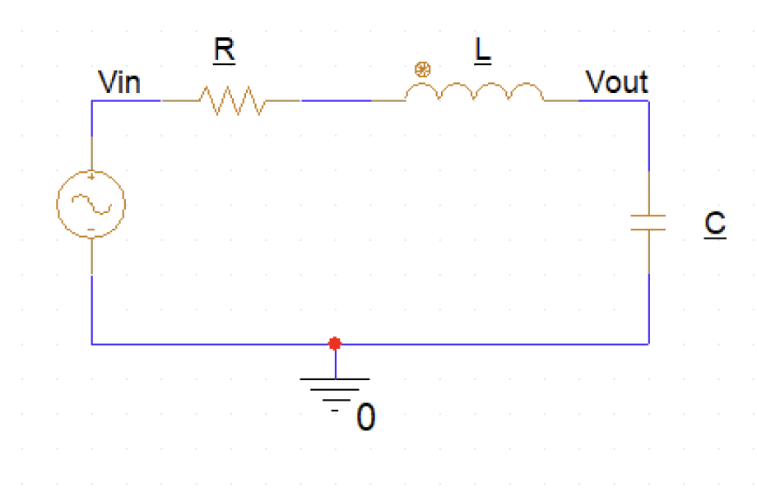

#### Figure 1: Schematic of Low-Pass filter

Using a voltage divider, the voltage output over voltage input is the transfer function of the circuit. Then we had to find the frequency response of the circuit by writing and 𝜁 in terms of R, L, and C. We used MATLAB to plot every 𝜁 value for |H(j)| vs . Then we used MATLAB to plot two types of plots, magnitude squared in dB vs. log frequency and degrees vs. log frequency.

## Section 2: High-pass and Band-pass RLC circuits:

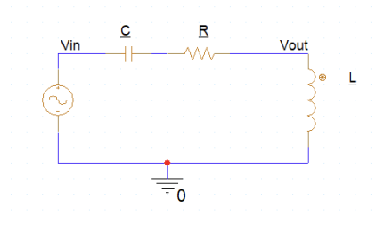

#### Figure 2: Schematic of High-Pass filter

We found the transfer function of the high-pass filter in terms of R, L, and C. The denominator is the same as the low-pass filter so we have to change the numerator by writing and 𝜁 in terms of R, L, and C. Using MATLAB, we modified our scripts and made the Bode plots of H(j) for the high-pass filter.

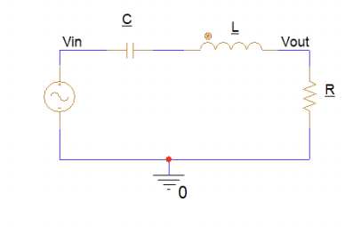

#### Figure 3: Schematic of Band-Pass filter

The procedure was almost identical to the high-pass filter. This time we had a different numerator which can also be called the gain and changed it by writing and 𝜁 in terms of R, L, and C.

## 

## Section 3: Mystery Filter

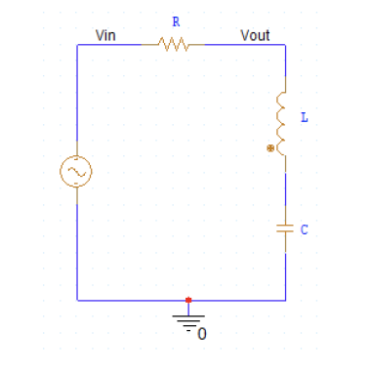

#### Figure 4: Schematic of Mystery Filter

The procedure was to do the same thing we did for problems 1 and 2. We found the transfer function and the frequency response. Then we proceeded to plot on MATLAB.

# Results

* For hand-calculations, refer to ‘Z’ as Zeta (ζ) *

## Section 1: Low-Pass RLC Circuit

### 

### 

### 

### Part A)

Find the transfer function, , in the above low-pass RLC filter circuit.

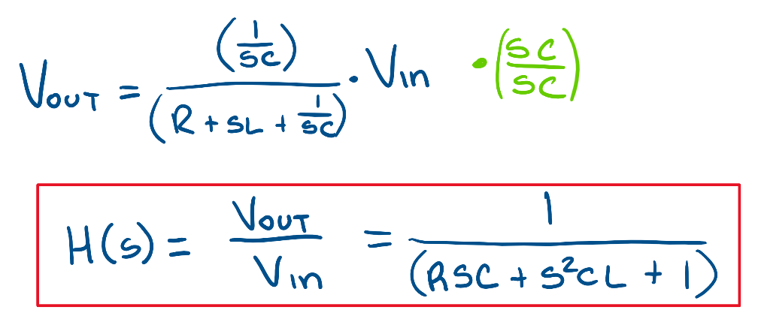

### 

### 

### Part B)

The frequency response of the circuit can be written as . Write and ζ in terms of R, L, and C.

### 

### 

### 

### Part C)

Write a MATLAB script to calculate and plot the magnitude and phase of for = 1 and ζ = [ 0.1, 0.3, 0.707, 1.0, 3.0, 10.0].

ii. Plot of Magnitude and Phase

### 

#### Figure 5: Magnitude plot of low-pass in Linear Scale

We see that this plot is hard to read on linear axes. We can see the magnitude vs frequency based on the ζ value.

iii. Bode Plot

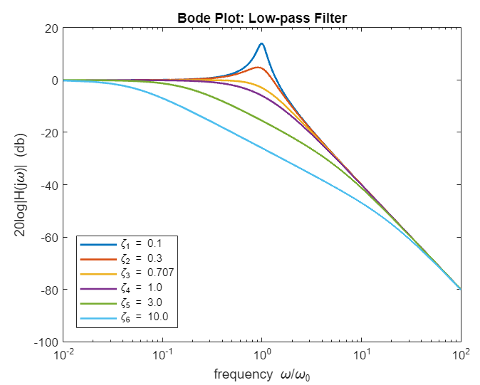

#### Figure 6: Magnitude plot of low-pass filter in dB vs log frequency

iv. Phase Plot

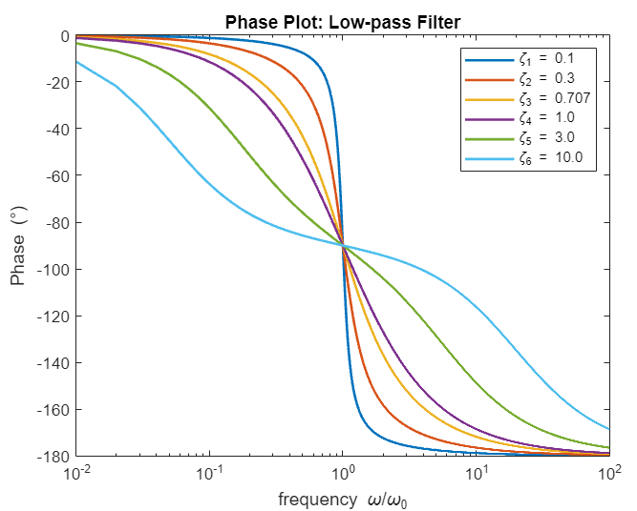

#### Figure 7: Phase plot of low-pass filter

### We can see that lower frequencies are passed through and all the higher frequencies are rejected.

### Part D)

When the damping factor ζ is less than 0.707, a peak occurs in . Analytically, find expressions for the peak frequency, , and in term of and ζ. Assuming = 1, calculate the values of for ζ = 0.1 and 0.3. Also find at these two values. Do these values agree with the peaks in your MATLAB figures for ζ = 0.1 and 0.3?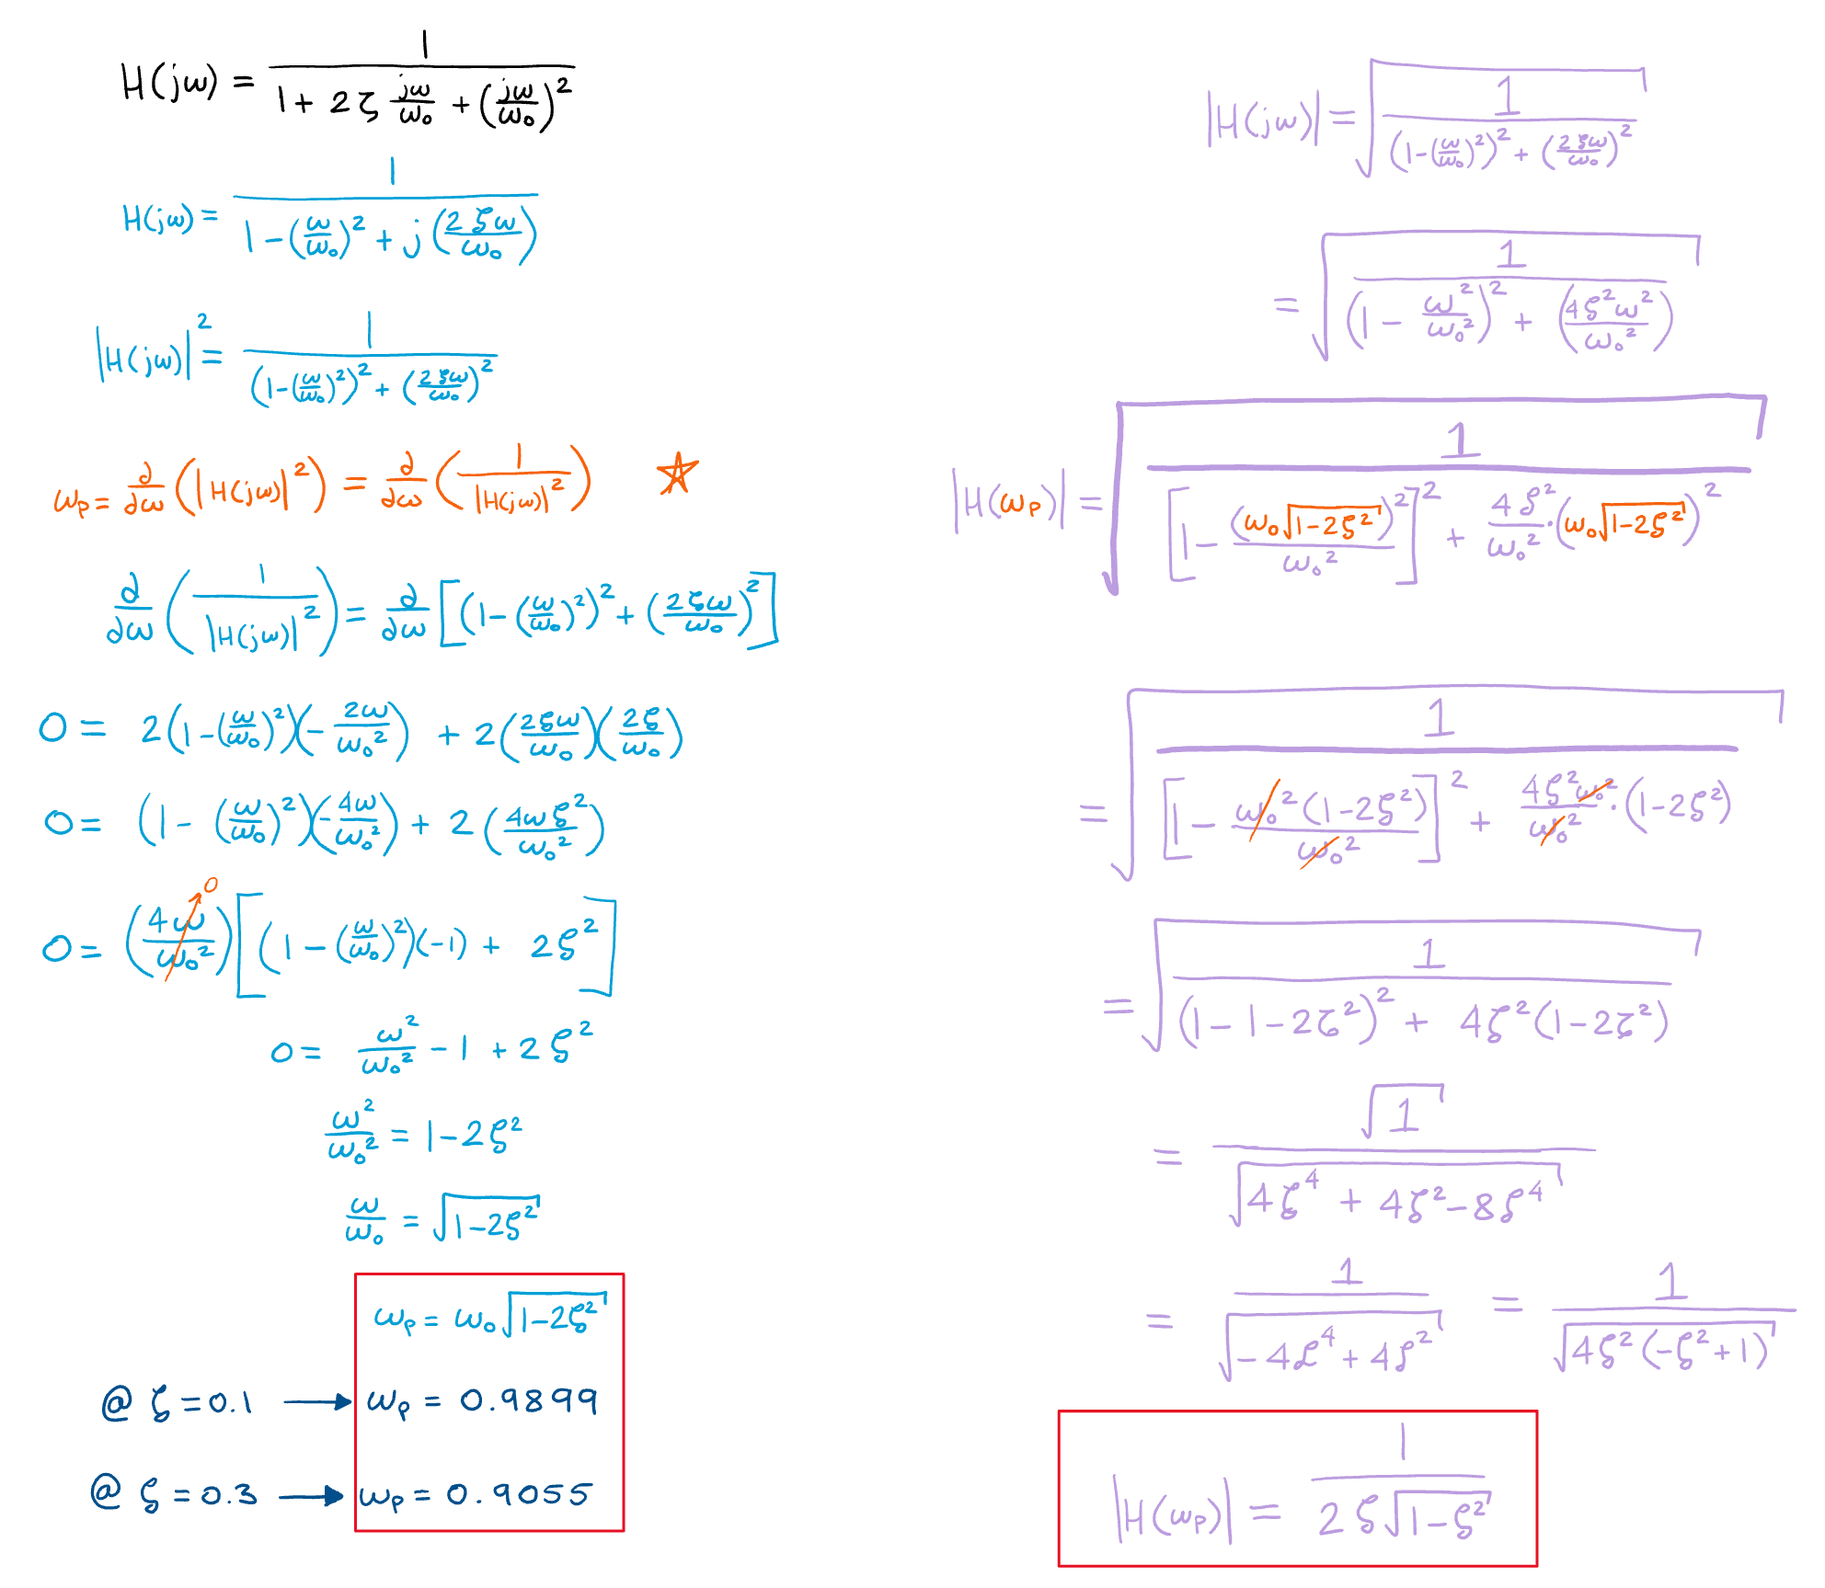

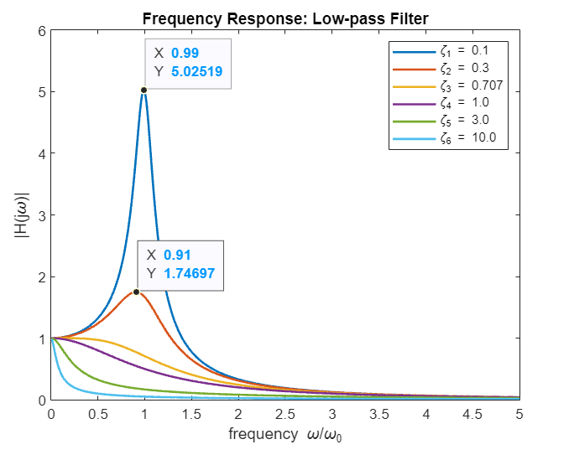

#### Figure 8: Magnitude plot of low-pass filter with Peak Values Labeled

Yes, these numbers match up with the results we calculated above. We noticed that the peak gets sharper and more narrow as decreases.

## 

## 

## Section 2: High-pass and Band-pass RLC Circuits

### 

### Part A)

Write the transfer functions and in terms of R, L, and C. Put them in the generalized form so the denominator is the same as the one for and the numerator is written in terms of s, and ζ.

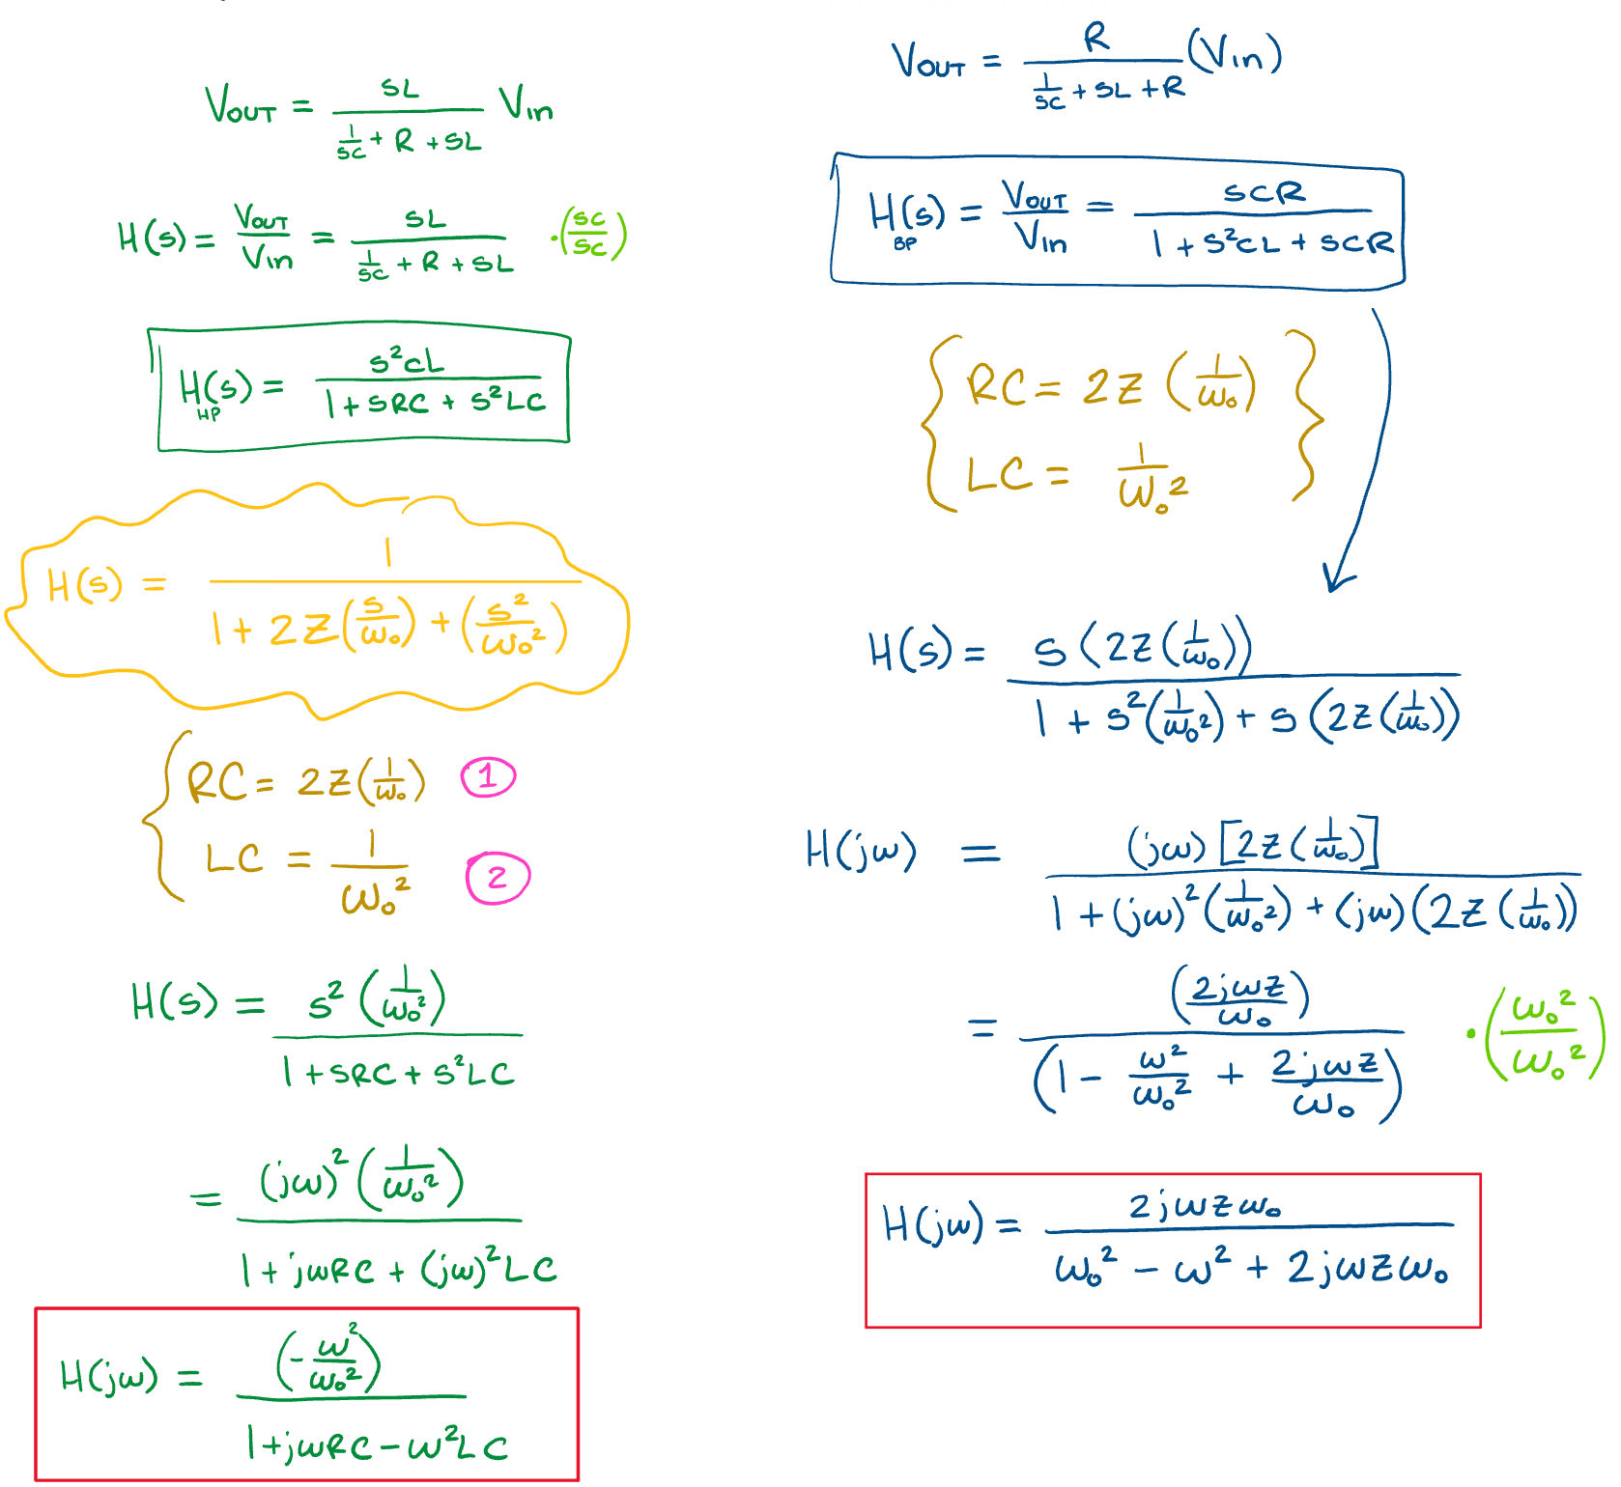

### Part B)

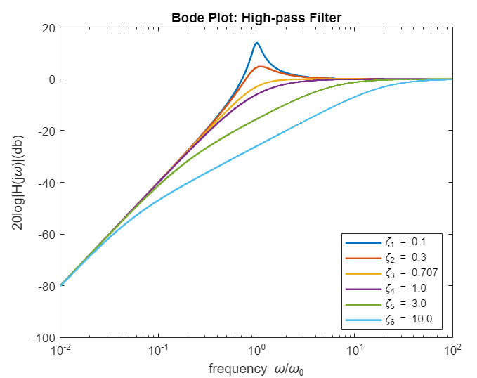

#### Figure 9: Magnitude plot of high-pass filter in dB vs log frequency

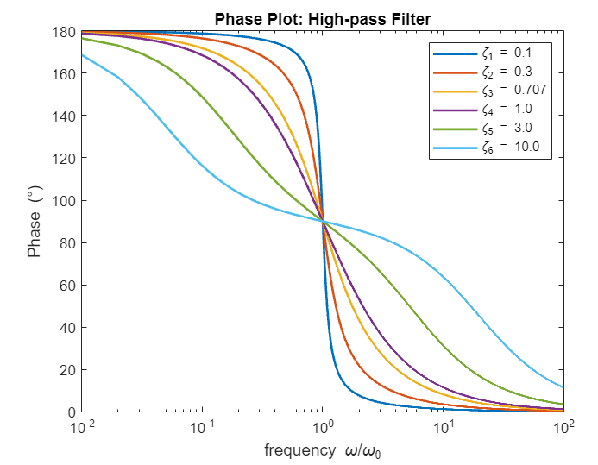

#### Figure 10: Phase plot of high-pass filter

We can see that lower frequencies are rejected and higher frequencies are allowed to pass through.

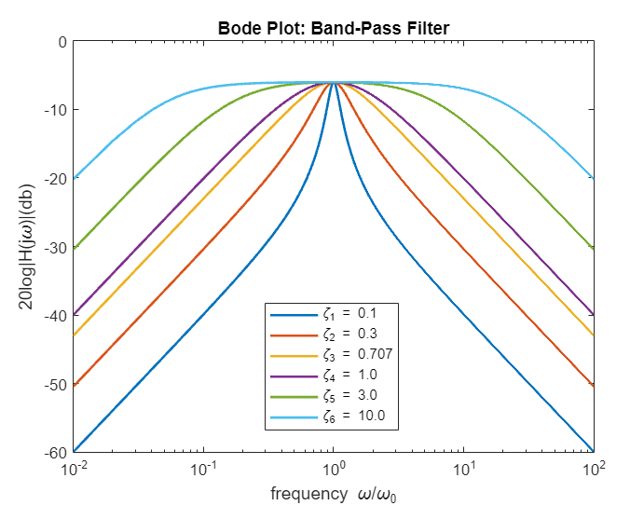

#### Figure 11: Magnitude plot of band-pass filter in dB vs log frequency

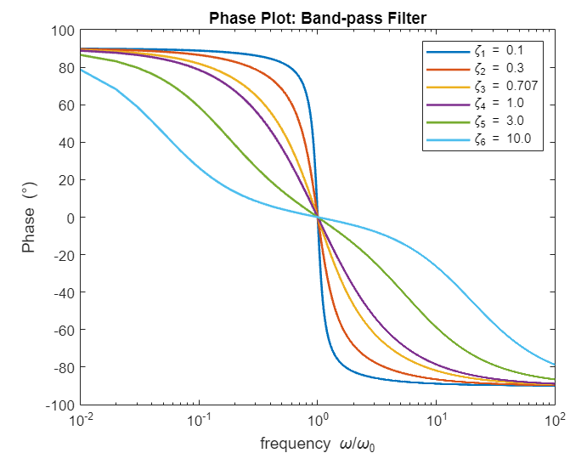

Figure 12: Phase plot of band-pass filter

We see that this allows a selected range of frequencies and rejects everything else that is out of the range.

## Section 3: Mystery Filter

## 

What happens if you take the output across C and L together rather than just one? Write the transfer function and plot the Bode plots for as you did for the band-pass and high-pass filters. What could you use this circuit for?

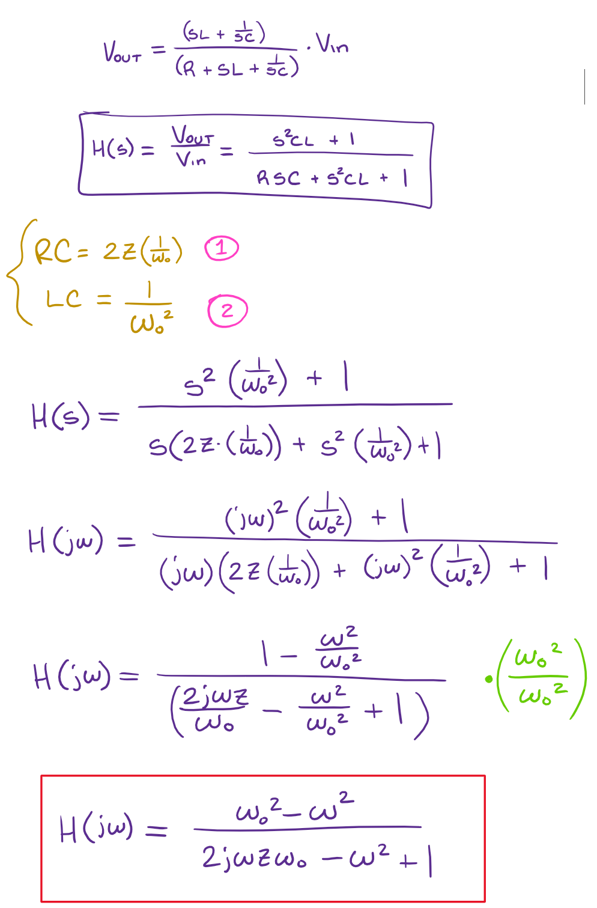

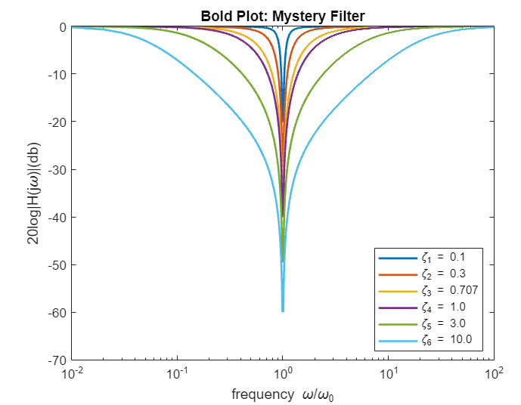

#### Figure 13: Magnitude plot of mystery filter in dB vs log frequency

We can see that when = it rejects the frequency and allows it to pass when they are not equal. This eliminates all frequencies within a band of frequencies

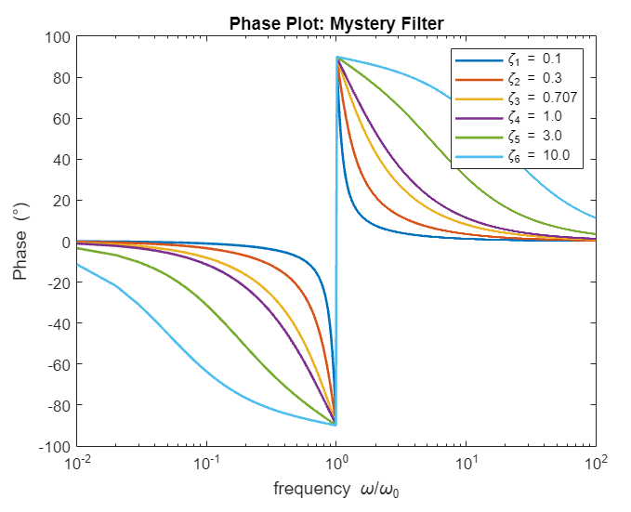

#### Figure 14: Phase plot of mystery filter

We found that this is a band-stop filter. We came to this conclusion because when = 1 and

= 1 the output would be 0. However, when is not equal to , the filter will allow the signal to pass. We think this would be really useful for noise cancellation because you can select the frequencies you don’t want to hear and cancel them out. When we took the output out of both C and L, we noticed that there was a difference in resonance.

## Section 4: Linear System Tools

MATLAB can also do symbolic algebra, including Laplace transforms. It has several tools that are very useful for analyzing linear systems. For example, the code below will produce Bode plots and step response plots for the circuits you analyzed above:

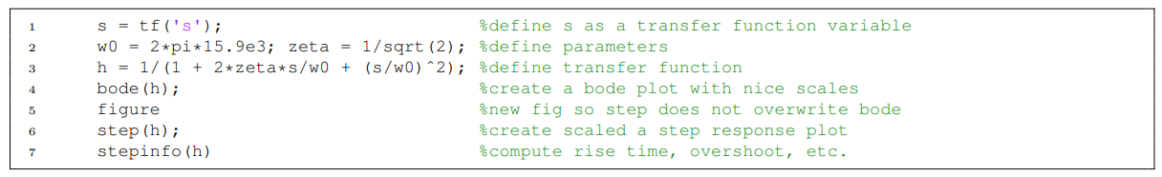

### Part A)

Use these tools to create a single plot with all the step responses for the transfer functions in Part 1c.

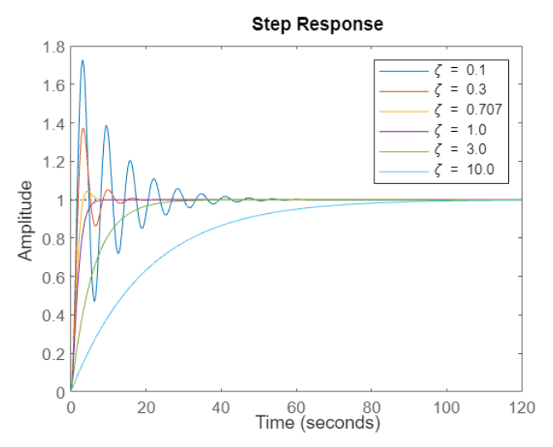

#### Figure 15: Step Response of low-pass filter

We noticed that if > 1, the step response will have an exponential curve. If < 1, The step response will have an oscillatory part. We also see that = 0.707 represents maximally flat and

= 1 is critically damped.

### Part B)

Overshoot of the step-response of a second-order low-pass filter: for and for ζ > 1. Plot the theoretical Overshoot Values vs. ζ for 0.01 < ζ < 10. Use a solid line for plotting the theoretical values. Next, find the overshoot values for each step response in part 1c with the help of the stepinfo function. Overlay the plot of these calculated overshoot values on your current plot. Show these values as a series of symbols, not a solid line.

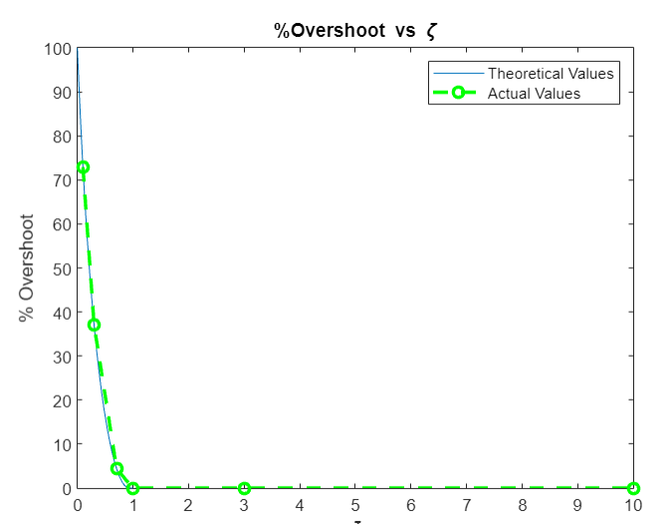

#### Figure 16: Overshoot % vs ζ

After normalization, we see that as decreases, the rise time decreases and the overshoot increases. From the graph, we see that = has the slowest rise time but no overshoot and = 0.1 has the fastest rise time but high overshoot.

# Conclusion

By doing this experiment we were able to show that rearranging an RLC circuit can be used to create different filters and block out unwanted frequencies. The low-pass blocked any high frequencies, the high-pass blocked any low frequencies, and the band-pass only allowed frequencies between specific values to pass through. We saw that the smaller the pole, the longer the rise time and less overshoot. We found that the damping coefficient () helps control and set the amount of overshoot and rise time. = 0.1 gave us the fastest rise time but the most overshoot and = 10 gave us the slowest rise time but no overshoot.Overall our calculations matched our MATLAB simulations.

# MATLAB Code

## 

## Problem 1: Low-pass RLC Circuit:

clear all; clc;

%z = [0.1 0.3 0.707 1.0 3.0 10.0];

w = 0.01:0.01:100;

z = [0.1 0.3 0.707 1.0 3.0 10.0];

w_0 = 1;

h2 = ones(6,10000);

%Magnitude vs frequency Graph

for counter = 1:1:6

h1 = 1./(1 + ((2.*z(counter).*w.*1i)./w_0) + (1i.*w).^2);

h2 = abs (h1);

figure (1);

plot (w,h2,'LineWidth', 1.1);

hold on

end

title( "Frequency Response: Low-pass Filter")

legend ("\zeta_1 = 0.1","\zeta_2 = 0.3","\zeta_3 = 0.707","\zeta_4 = 1.0","\zeta_5 = 3.0","\zeta_6 = 10.0" )

xlabel ("frequency \omega/\omega_0")

ylabel("|H(j\omega)|")

xlim([0 20])

hold off

%Magnitude vs frequency Better Visual

for counter = 1:1:6

h1 = 1./(1 + ((2.*z(counter).*w.*1i)./w_0) + (1i.*w).^2);

h2 = abs (h1);

figure (2);

plot (w,h2,'LineWidth', 1.5);

hold on

end

title( "Frequency Response: Low-pass Filter")

legend ("\zeta_1 = 0.1","\zeta_2 = 0.3","\zeta_3 = 0.707","\zeta_4 = 1.0","\zeta_5 = 3.0","\zeta_6 = 10.0" )

xlabel ("frequency \omega/\omega_0")

ylabel("|H(j\omega)|")

xlim([0 5])

zeta_101 = findobj(gcf, "DisplayName", "\zeta_1 = 0.1");

datatip(zeta_101,0.99,5.025);

zeta_203 = findobj(gcf, "DisplayName", "\zeta_2 = 0.3");

datatip(zeta_203,0.91,1.747);

hold off

%Bode Plot :LPF

for counter = 1:1:6

h1 = 1./(1 + ((2.*z(counter).*w.*1i)./w_0) + (1i.*w).^2);

h2 = abs (h1);

hdb = 20.*log10(h2);

figure (3);

semilogx (w,hdb,'LineWidth', 1.5);

hold on

end

title( "Bode Plot: Low-pass Filter")

legend ("\zeta_1 = 0.1","\zeta_2 = 0.3","\zeta_3 = 0.707","\zeta_4 = 1.0","\zeta_5 = 3.0","\zeta_6 = 10.0" )

xlabel ("frequency \omega/\omega_0")

ylabel("20log|H(j\omega)| (db)")

legend("Position", [0.15612,0.14203,0.19801,0.25058])

hold off

%Phase Plot: LPF

for counter = 1:1:6

h1 = 1./(1 + ((2.*z(counter).*w.*1i)./w_0) + (1i.*w).^2);

ph = (angle(h1)).*(180/pi);

figure (4);

semilogx(w,ph,'LineWidth', 1.5);

hold on

end

title( "Phase Plot: Low-pass Filter")

legend ("\zeta_1 = 0.1","\zeta_2 = 0.3","\zeta_3 = 0.707","\zeta_4 = 1.0","\zeta_5 = 3.0","\zeta_6 = 10.0" )

xlabel ("frequency \omega/\omega_0")

ylabel("Phase (\circ)")

hold off

## Problem 2: High-pass and Band-pass RLC circuits:

z = [0.1 0.3 0.707 1.0 3.0 10.0];

w_0 = 1;

h2 = ones(6,10000);

% Bode Plot:high pass filter

for counter = 1:1:6

h1 = ((1i*w)./w_0).^2./(1 + ((2.*z(counter).*w.*1i)./w_0) + (1i.*w).^2);

h2 = abs (h1);

hdb = 20.*log10(h2);

figure (5);

semilogx (w,hdb,'LineWidth', 1.5);

hold on

end

title( "Bode Plot: High-pass Filter")

legend ("\zeta_1 = 0.1","\zeta_2 = 0.3","\zeta_3 = 0.707","\zeta_4 = 1.0","\zeta_5 = 3.0","\zeta_6 = 10.0" )

xlabel ("frequency \omega/\omega_0")

ylabel("20log|H(j\omega)|(db)")

legend("Position", [0.68568,0.13177,0.19801,0.25058])

hold off

%Phase Plot :HPF

for counter = 1:1:6

h1 = ((1i*w)./w_0).^2./(1 + ((2.*z(counter).*w.*1i)./w_0) + (1i.*w).^2);

ph = (angle(h1)).*(180/pi);

figure (6);

semilogx(w,ph,'LineWidth', 1.5);

hold on

end

title( "Phase Plot: High-pass Filter")

legend ("\zeta_1 = 0.1","\zeta_2 = 0.3","\zeta_3 = 0.707","\zeta_4 = 1.0","\zeta_5 = 3.0","\zeta_6 = 10.0" )

xlabel ("frequency \omega/\omega_0")

ylabel("Phase (\circ)")

hold off

%band-pass bode plot

for counter = 1:1:6

h1 = (1i.*w.*z(counter))./(1 + ((2.*z(counter).*w.*1i)./w_0) + (1i.*w).^2);

h2 = abs (h1);

hdb = 20.*log10(h2);

figure (7);

semilogx (w,hdb,'LineWidth', 1.5);

hold on

end

title( "Bode Plot: Band-pass Filter")

legend ("\zeta_1 = 0.1","\zeta_2 = 0.3","\zeta_3 = 0.707","\zeta_4 = 1.0","\zeta_5 = 3.0","\zeta_6 = 10.0" )

xlabel ("frequency \omega/\omega_0")

ylabel("20log|H(j\omega)|(db)")

legend("Position", [0.41609,0.15486,0.19801,0.25058])

hold off

%Phase Plot :Band-Pass

for counter = 1:1:6

h1 = (1i.*w.*z(counter))./(1 + ((2.*z(counter).*w.*1i)./w_0) + (1i.*w).^2);

ph = (angle(h1)).*(180/pi);

figure (8);

semilogx(w,ph,'LineWidth', 1.5);

hold on

end

title( "Phase Plot: Band-pass Filter")

legend ("\zeta_1 = 0.1","\zeta_2 = 0.3","\zeta_3 = 0.707","\zeta_4 = 1.0","\zeta_5 = 3.0","\zeta_6 = 10.0" )

xlabel ("frequency \omega/\omega_0")

ylabel("Phase (\circ)")

hold off

### 

## 

## Problem 3: Mystery Filter

z = [0.1 0.3 0.707 1.0 3.0 10.0];

w_0 = 1;

h2 = ones(6,10000);

for counter = 1:1:6

h1 = (1-w.^2)./(1 + (2.*z(counter).*w.*1i) + (1i.*w).^2);

h2 = abs (h1);

hdb = 20.*log10(h2);

figure (9);

semilogx (w,hdb,'LineWidth', 1.5);

hold on

end

title( "Bold Plot: Mystery Filter")

legend ("\zeta_1 = 0.1","\zeta_2 = 0.3","\zeta_3 = 0.707","\zeta_4 = 1.0","\zeta_5 = 3.0","\zeta_6 = 10.0" )

xlabel ("frequency \omega/\omega_0")

ylabel("20log|H(j\omega)|(db)")

legend("Position", [0.68568,0.13177,0.19801,0.25058])

hold off

%Phase Plot Band-Pass

for counter = 1:1:6

h1 = (1-w.^2)./(1 + (2.*z(counter).*w.*1i) + (1i.*w).^2);

ph = (angle(h1)).*(180/pi);

figure (10);

semilogx(w,ph,'LineWidth', 1.5);

hold on

end

title( "Phase Plot: Mystery Filter")

legend ("\zeta_1 = 0.1","\zeta_2 = 0.3","\zeta_3 = 0.707","\zeta_4 = 1.0","\zeta_5 = 3.0","\zeta_6 = 10.0" )

xlabel ("frequency \omega/\omega_0")

ylabel("Phase (\circ)")

hold off

### 

## 

## Problem 4: Linear System Tools

### a) Step Responses for Transfer Functions

s = tf('s');

omega_0 = 1;

z = [0.1 0.3 0.707 1.0 3.0 10.0];

%bode(h);

for counter = 1:1:6

h = 1/(1 + 2.*z(counter).*(s/omega_0) + (s/omega_0)^2);

figure (11)

step(h);

stepinfo(h,'LineWidth', 1.5);

hold on

end

title("Step Response")

legend ("\zeta = 0.1","\zeta = 0.3","\zeta = 0.707","\zeta = 1.0","\zeta = 3.0","\zeta = 10.0" )

xlabel ("Time")

ylabel("Amplitude")

hold off

### 

### b) Plot Overshoot

zeta = 0:0.01:1;

percent_overshoot = 100.*exp(1).^((-pi.*zeta)./sqrt(1-(zeta.^2)));

figure (13);

plot(zeta,percent_overshoot)

hold on

title("%Overshoot vs \zeta")

xlabel("\zeta")

ylabel("% Overshoot")

xlim([0 10])

z = [0.1 0.3 0.707 1.0 3.0 10.0];

overshoot = [72.9156 37.1410 4.3251 0 0 0];

plot (z , overshoot, 'g--o','LineWidth', 2);

legend ('Theoretical Values', 'Actual Values')

hold off